|  |  |
| --- | --- |
| **School: Gia Hoa primary school**  **Class: 3____**  **Full name: ………………………………...** | **The 2nd Term Semester Exam**  **School year: 2016- 2017**  **Time: 40 minutes** |

­­­­­­

|  |  |  |  |  |  |  |
| --- | --- | --- | --- | --- | --- | --- |
| **Mark** | **Listening** | **Reading** | **writing** | **Speaking** | **Total** |  |
|  |  |  |  |  |

**I. LISTENING**

**PART 1: Listen and number.(0,5pt)**

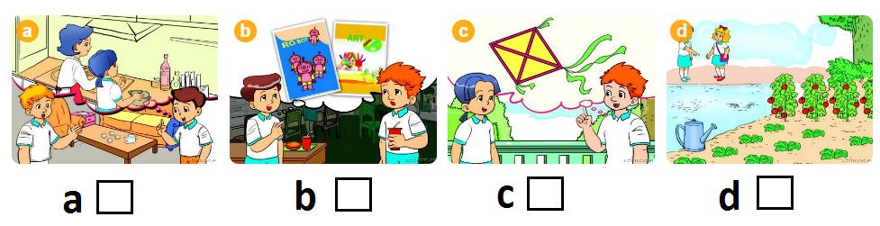

**PART 2. Listen and tick T or F . (1pt)**

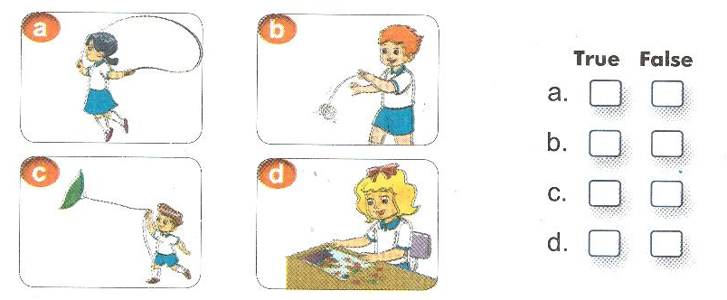

**PART 3: Listen and complete . (1pt)**

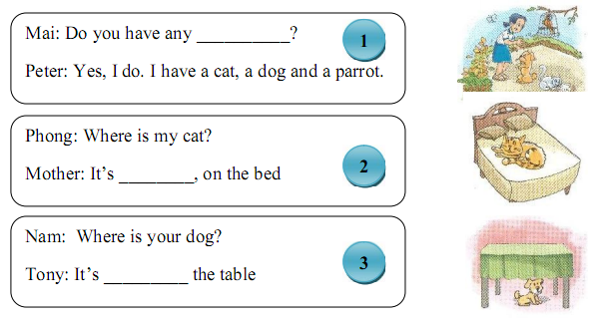

**PART 4: Listen and circle. (1 pt)**

0. Where are you Hoa? - I'm in my room.

What are you doing there? I'm **reading / cooking**

1. Do you have **an / any** pets ? - I have two parrots.

2. What toys do you like ? I like **trucks / ship.**

3. Do you have a rabbit? **No, I don't / Yes, I do.**

4. What's the weather like? It's **stormy / snowy.**

5. Where 's SaPa ? - It's in **north / central** Viet Nam.

**II. READING :**

**PART 1. Read and match. (1pt)**

|  |  |  |
| --- | --- | --- |
| 0. What's the weather like ? |  | a. He's thirty - eight years old. |
| 1. How old is your father ? | b. She's flying kite. |
| 2. What is she doing? | c. There are three. |
| 3. Is there a fence? | d. No, there isn't. |
| 4. How many books are there ? | e. It's sunny. |

**PART 2. Read and tick (1pt).**

*Hi, my name is Hoa. There are four people in my family: my parents, my brother and me. My father is a doctor. He is forty-four. My mother is a teacher. She is forty-two. She is shorter than my father. Nam is my brother. He is fifteen years old. He is slimmer than me. He and I are students. I am nine. I am big and short. We are a happy famiy.*

Tick Yes or No  *Yes No*

*✓*

***0. There are four members in Hoa’s family.***

***1. Her mother is forty years old.***

***2. Her father is forty - four .***

***3. Hoa is ten years old***

**PART 3. Read and put a tick ☑ or a cross 🗵 in the box as examples. (0,5 pt)**

|  |  |  |  |
| --- | --- | --- | --- |
|  | 0. This is a pen. | | **☑** |
|  | | | 00. This is a pencil. | **🗵** |

|  |  |  |
| --- | --- | --- |
| vet2 | 1. Nam has one parrot. | 🞏 |
| do-choi-mo-maisto-may-bay-sieu-anh-hung-marvel-iron-man-15171-20121127-0 | 2. This is a car. | 🞏 |
| teddy-bear-day-1a | 3. She has three teddy bears. | 🞏 |
| https://s.sachmem.vn/public/images/TA3T2SHS/U19-L2-5-1-tekvpcjpdtefurya.jpg | 4. It's sunny in Ha Noi today. | 🞏 |

**III. WRITING :**

**PART 1: Read and complete. (1pt)**

*Hi. My name is Nam. I am in the playroom with my friends. I like planes. Mai likes dolls. Quan and Phong like ships. Linda likes kites. Peter and Tony like trucks. We have a lot of fun in the playroom.*

0. The children are in the playroom .

1. Mai likes  ___________________.

2. Quan and Phong like ___________________ .

3. Linda likes  ______________________________.

4. Peter and Tony like  __________________.

**PART 2. Order the words. (0,5 pt)**

Example:

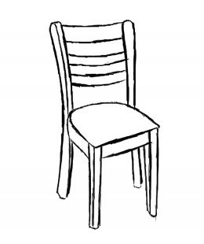

chair

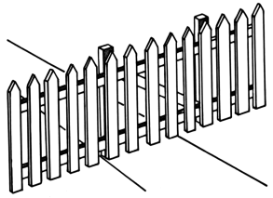 1. **_ _ _ _ _**

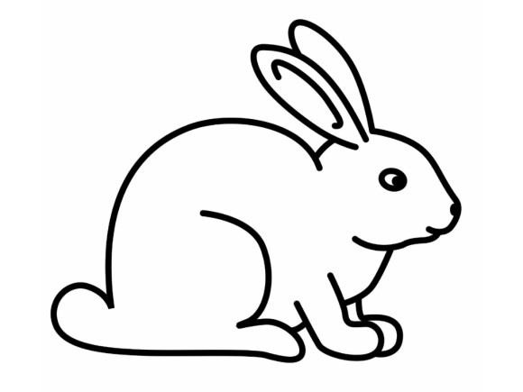 2. **_ _ _ _ _ _**

**IV. SPEAKING (2,5 pt):**

**1. Introduce yourself.**

- My name is ……I am …. years old. I am a student at ……Primary school.

**2. Responding.**

1. How are you today? …
2. What toys do you like? ......
3. How many dogs do you have? .......
4. What’s the weather like, today? ….
5. What pets do you have? ......
6. Where is the Can Tho? ….
7. Do you like toys? …
8. How old is your mother/father/sister? ….

--- The end ---

**AUDIO SCRIFT AND KEY**

**I. LISTENING (10 Minutes)**

**PART 1. Listen and number. (0,5pt)**

**KEY: 1 a. 2 c. 3 b. 4 d.**

**PART 2. Listen and T or F . (1pt)**

**KEY: 1T. 2F. 3T. 4F.**

**PART 3. Listen and complete. (1pt)**

1. pets

2. here

3. under

4. rabbits

**PART 4. Listen and circle.**

**Key: 1. Any 2.trucks 3. No, I don't 4. Snowy.** 5. north

**II: READING**

**PART 1. Read and MATCH.**

**Key:** 1 -a 2- b 3-d 4-c

**PART 2. Read and tick T or F .**

**Key**: 1 – F. 2 – T. 3 – T. 4 – F.

**PART 3.**

|  |  |  |
| --- | --- | --- |
| vet2 | 1. Nam has one parrot. | **☑** |
| do-choi-mo-maisto-may-bay-sieu-anh-hung-marvel-iron-man-15171-20121127-0 | 2. This is a car. | **🗵** |
| teddy-bear-day-1a | 3. She has three teddy bears. | **☑** |
| https://s.sachmem.vn/public/images/TA3T2SHS/U19-L2-5-1-tekvpcjpdtefurya.jpg | 4. It's sunny in Ha Noi today. | **🗵** |

**III: WRITING**

**PART 1: Read and complete.**

**Key:** 1. dolls 2. ships 3. kites 4. trucks

**PART 2. Order the words.**

Key: 1. fence 2 . rabbit

**IV. SPEAKING**

**1. Introduce yourself.**

- My name is ……I am …. years old. I am a student at ……Primary school.

**2. Responding.**

1. How are you today? …
2. What toys do you like? ......
3. How many dogs do you have? .......
4. What’s the weather like, today? ….
5. What pets do you have? ......
6. Where is the Can Tho? ….
7. Do you like toys? …
8. How old is your mother/father/sister? ….